39.49: a) 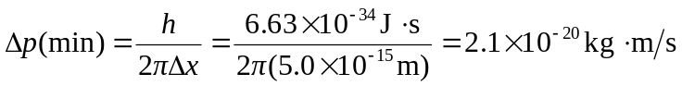
b) 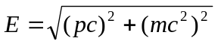
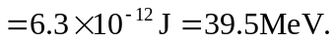
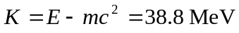
c) The coulomb potential energy is 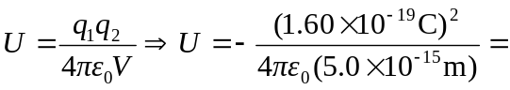

Hence there is not enough energy to “hold” the electron in the nucleus.

